**By Sri Pranathi Challagolla**

**Shift Registers:**

* Shift registers are sequential circuits that store and move binary data through flip-flops in response to clock pulses.
* They come in four types: SISO, SIPO, PISO, and PIPO, based on serial/parallel input-output configurations.
* Common uses include data buffering, serialization, delay elements, and digital signal processing.
* Implementation involves clocked flip-flops with controlled data routing via multiplexers or direct wiring.

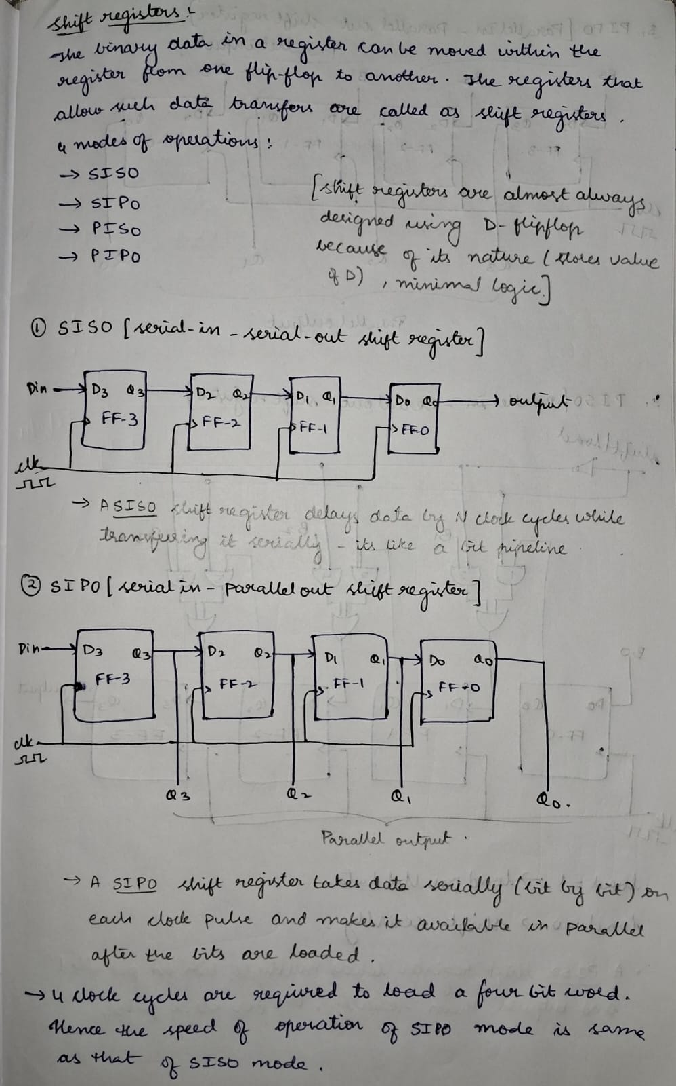

**1.Implemented SISO shift register:**

**Design:**

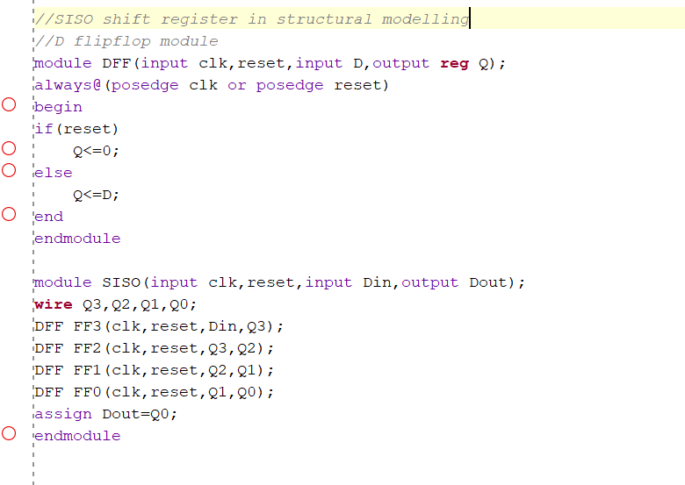

**Testbench :**

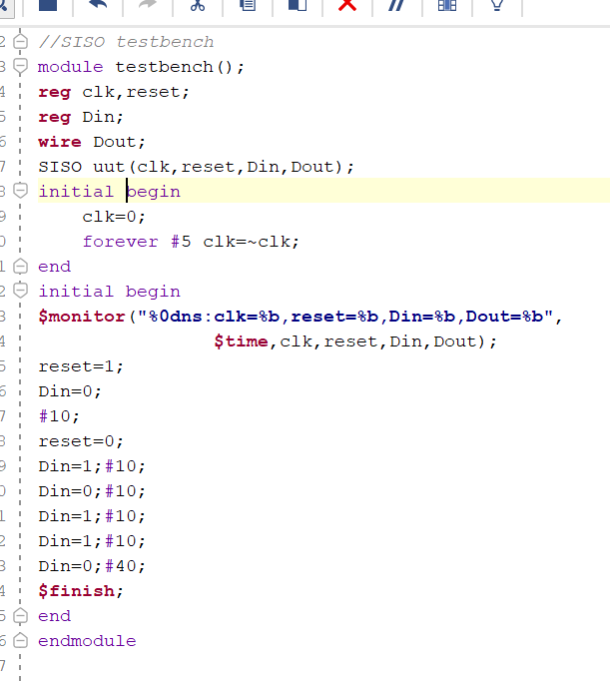

**2.Implemented SIPO shift register:**

**Design:**

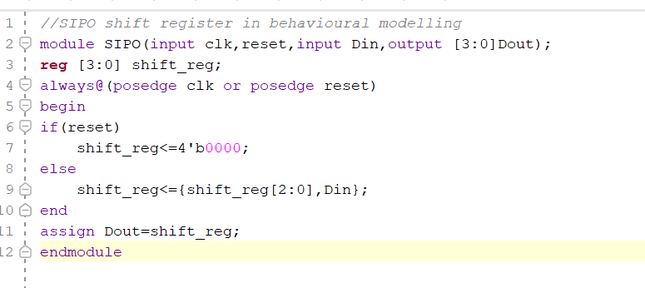

**Testbench:**

**3.Implemented PIPO shift register:**

**Design:**

**Testbench:**

**4.Implemented PISO shift register:**

**Design:**

**Testbench:**

